Day 2 Assignments
- Assignment 1
Design this table (5*3)
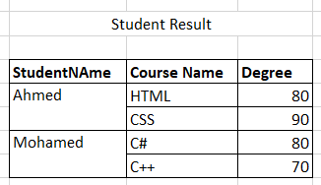
- Assignment 2:
Make iframe that open any youtube video
- Assignment 3:
  - Create Registration page with the following fields (Don’t use tables with the form):
  - User ID (Hidden field)
  - First name (Required)
  - Last Name (Required)
  - Email (Required, Email)
  - Password (password)
  - Repeat password (password)
  - Birth Date (Date)
  - User Picture (file input)
  - Gender [Male of Female] (Radio button, in fieldset)
  - Faculty (Dropdown list)
  - Interests [Programming, reading, swimming,..](Checkbox in fieldset)
  - About you (Text area)
  - I agreed to terms and condition checkbox (make the label next to it as a link to terms and condition page that opens in new tab)
  - Submit and reset buttons
Use the following with the form:
- Labels instead of plain text for form elements
- Adjust tab index and use access key.
- HTML 5 new inputs and validation attributes.
- Submit button redirect user to page named (Thankyou.htm), which contains text:

Self study :
- Search about fieldset Element and Legand:
https://www.w3schools.com/tags/tag_fieldset.asp

